Threshold comparisons

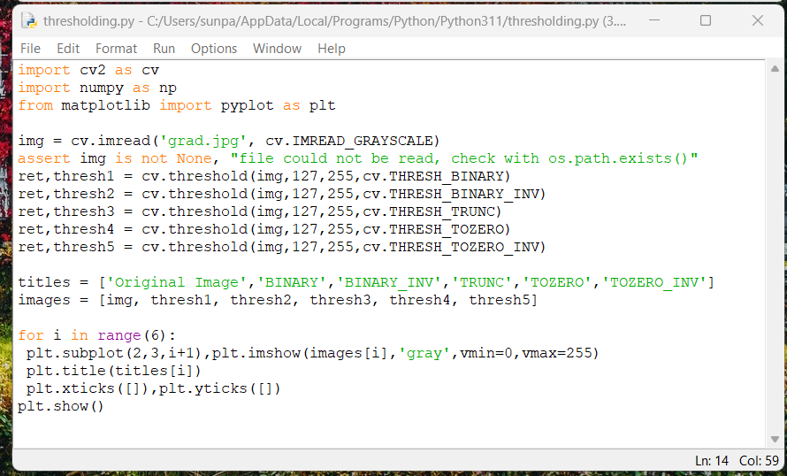

Adaptive mean Thresholding vs gaussian thresholding

Adaptive mean thresholding uses mean of neighborhood area minus a constant C

Gaussian uses the gaussian weighted sum of the neighbourhood values minus the constant C

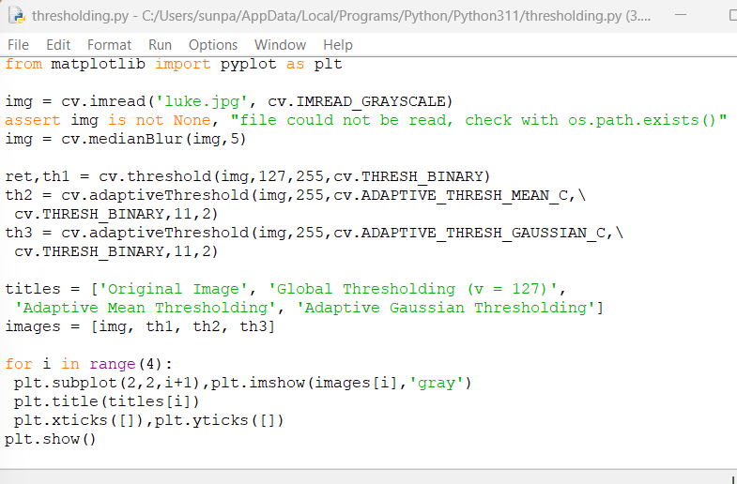

Output

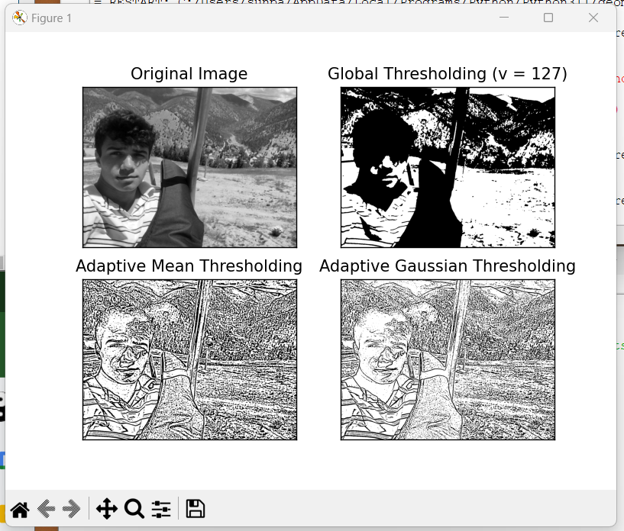

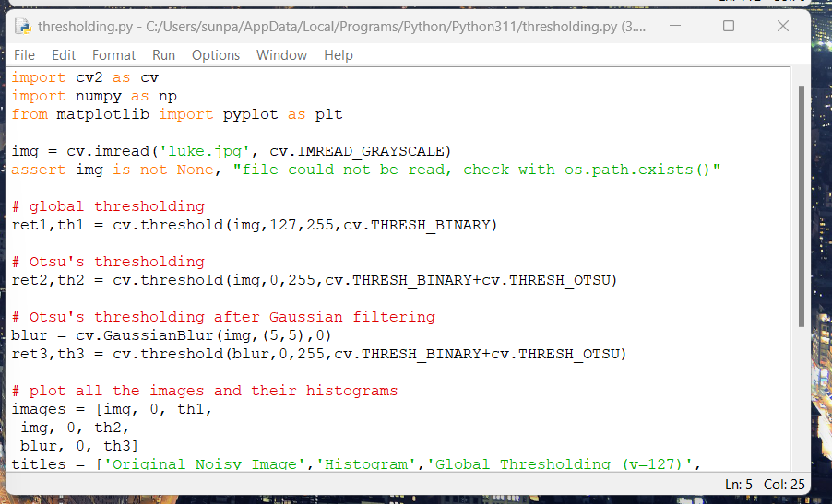

Threshold comparisons using Otsu’s thresholding, algorithm selects a threshold value depending on the distribution of grayscale value

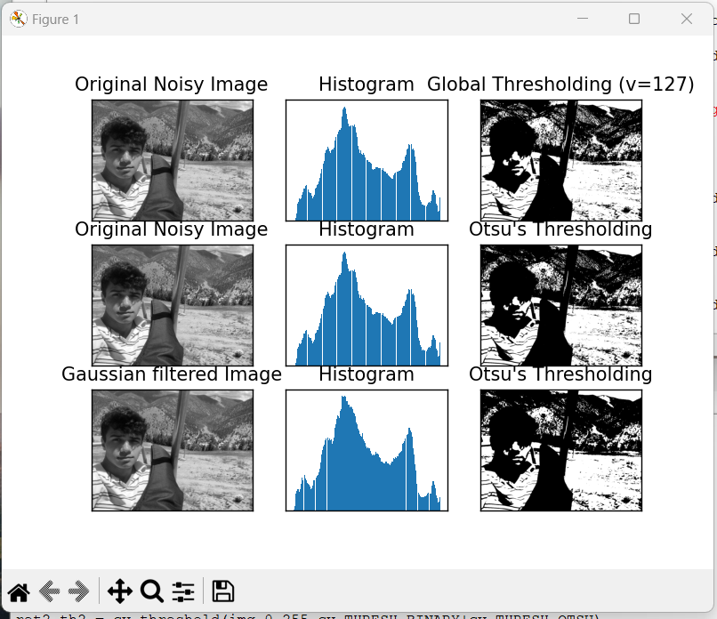

Output

Python implementation of Otsu’s Binarization along with built in Open CV function

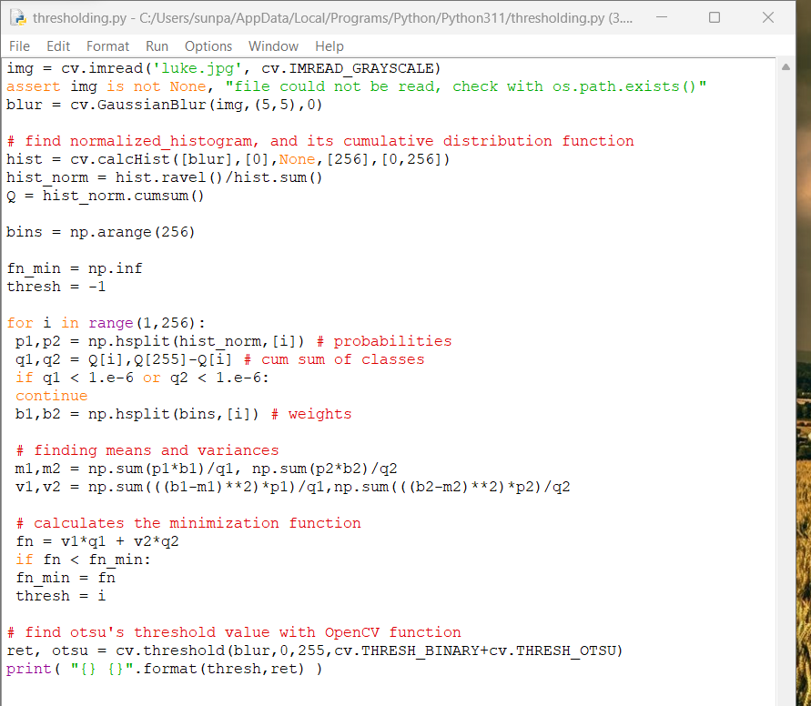

Outputs of both



